Equality Duty and Objectives
Challenging stereotypes and prejudice Preventing discrimination and misunderstanding Raising awareness and asking questions Allowing access and discussion
Encouraging kindness and respect Enabling potential and progress Celebrating difference and diversity

Northampton School for Boys is committed to ensuring all aspects of equality are fully addressed within an inclusive learning environment where everybody is valued and represented so that each student has the opportunity to fulfil their academic potential alongside their social, moral, spiritual and culture development. Alongside the academic curriculum students are taught and experience important core values and develop into healthy, resilient, critically thinking, empathic young adults who are fully prepared for life in modern Britain.

This document forms part of our mission statement in relation to The Respect Agenda – respect by all for all - with kindness, compassion and tolerance as key values. It is part of our commitment to meet the Public Sector Equality Duty (PSED) and the requirement to have due regard for the need to;
- eliminate discrimination and prejudice,
- provide a safe and secure learning environment,
- advance equality of opportunity and ensure quality of access,
- challenge stereotypes, negative attitudes and discriminatory language,
- foster good relations between those who share protected characteristics and those who do not,
- foster positive mental wellbeing
- celebrate diversity as well as identify our similarities.

It links with our Behaviour Policy, Anti-bullying policy, Disability Equality Scheme and Accessibility Plan, E-safety and Acceptable Use Policy, Additional Intervention Team and Special Educational Needs Policy, Child Protection Policy, Safeguarding of Young People Policy, Exclusions Policy, Relationships and Sex Policy and with our Personal, Social, Health and Economic Education programme (PSHE).

The Governing Body monitor and review the SEND policy and the Accessibility Plan annually alongside the other policies which have the promotion of equality firmly embedded within them. Senior Staff and students report back to the Governor Welfare Committee so they can ensure the School’s inclusion of students with protected characteristics meets all aspects of current legislation. Student voice through House and School Council, student surveys, online reporting tools, student ambassadors and focus groups, is integral to this.

The Headteacher and the Senior Leadership Team ensure that all policies, practices, protocols and provision have regard to the Disability Equality Duty and the Equality Act of 2010, which extends protection from discrimination to people with protected characteristics in almost every area of school life. The Headteacher, members of the Senior Leadership team and the SENCO are responsible for ensuring the implementation of all policies, monitoring aspects of this and the full development of a strong ethos of inclusion, within all aspects of the life of the school. Decisions made at every level take into consideration the implications they may have for people with protected characteristics and this is regularly reviewed. The Pupil Welfare Panel meets regularly to discuss issues and the Pastoral Management team meet termly (minimum 6 times a year).

It is the duty of all staff working in the school to implement the policies and continue to develop inclusive practices.
Students are also encouraged to feedback through student voice drop ins, the student voice survey, House and School Council. The Student Leadership Team are also asked to feedback on policies.
Staff and parent feedback is also encouraged.

The Respect Agenda forms part of Personal Development and Wellbeing
It addresses the requirement for the school to ensure that students develop into good citizens who are respectful and fully prepared for life after school.

An Inclusive Learning Environment
Being part of a caring community means we must always be reasonable and treat others and their property with respect. Refrain from unnecessary physical contact with others, using inappropriate language, name-calling and teasing. These can all cause a lot of upset and hinder progress and learning. If an issue arises, students are encouraged to talk to subject teachers, Form or PSHE teacher or the Inclusion Team to ask for help. Parents/Carers, staff and students can also report a concern online. It is far better to be able to work with others in a pleasant and positive atmosphere.

Equality is the permission to be different and respected. It does not mean we are the same.

▪ Everyone should be treated in accordance with equality and human rights legislation.
▪ We do not allow anyone to discriminate against others because of their protected characteristics as these are all equal in law.
▪ We challenge those who breach our code.
▪ You do not have the right to discriminate against, harass or bully other persons.
▪ Whatever your religion or beliefs you must respect other people’s religion and beliefs and whatever your religion or beliefs you must respect people identifying as LGBTQ+ (lesbian, gay, bisexual or transgender as well as, for example, non-binary, gender fluid, pansexual, polysexual, aroace).
▪ If you are being harassed or bullied in, or outside the premises, report it. If you see someone else being bullied, report it.

No bystanders! Be an Upstander!
We are all responsible for each other’s wellbeing.
We respect each other’s differences and celebrate diversity.

Equality Act 2010, protected characteristics;
Race Disability Sex
Age
Religion or belief Sexual orientation
Pregnancy and maternity Gender reassignment
(Marriage and Civil Partnership)

These form the basis of equality work undertaken at NSB alongside economic inequality. These areas are covered within related policies, aspects within Personal, Social, Health and Economic Education (PSHE), Morning PD sessions, Personal Development Week, Assemblies, the curriculum, extra-curricular activities, awareness days/weeks/months and indeed all aspects of school life and in relation to the wider community. We have high expectations of our students and a strong belief in their ability and desire to uphold the ethos of the Respect Agenda and to contribute positively to community cohesion.

Social, Moral, Spiritual and Cultural Development (SMSC)

It is important that students develop into a well-rounded individual who adhere to British values and who develop into trustworthy, considerate, co-operative, friendly, honest, courteous and hardworking individuals with the ability to listen to the views of others and think critically.
Friendly
Co-operative
Honest
Considerate
Hardworking
Trusting
It is essential
that everyone of us is:
Courteous
It is important that students understand what SMSC development and core values are and there is a focus on this in PSHE, alongside our main welfare policies, our extra-curricular ethos and curriculum lessons as well as all the interactions within school and the wider community.

British values could be seen as universal or core values.

Core values are the guiding principles that dictate behaviour and action.
Core values can help people to know what is right from wrong.

Diversity
Tolerance
Courage
Kindness
Equality
Democracy
Safety
Respect
Our
Core Values
Justice

- Our core values shape how we are treated by others in school (including adults)
- Our core values share how we treat other people in school (including adults)
- Our core values tell other people outside of school how we treat each other

They represent our deeply held beliefs, our highest priorities, and the fundamental forces that drive our actions.

British Values;

- Preparing pupils positively for life in modern Britain and adhering to the fundamental British values of democracy, the rule of law, individual liberty and mutual respect for and tolerance of those with different faiths and beliefs and those without faith
- promoting all forms of equality and fostering greater understanding of and respect for people of all faiths or no faith, races, genders, ages, disability and sexual orientations through their words, actions and influence within the school and more widely in the community
opportunities for pupils to extend their knowledge and understanding and to improve their skills in a range of artistic and creative activities.

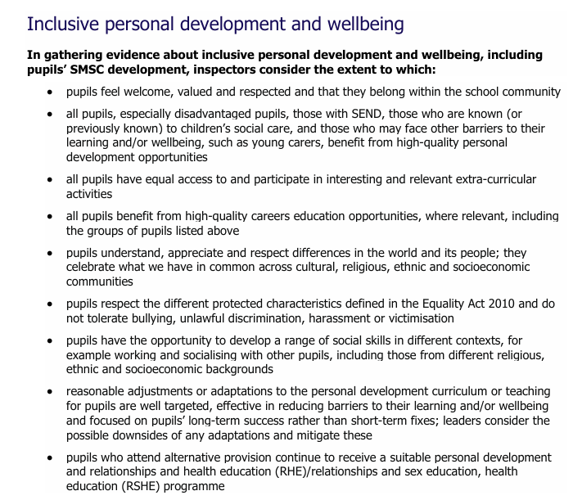
Taken from the new Ofsted Framework
SMSC Descriptors:

The spiritual development of pupils is shown by their:
▪ ability to be reflective about their own beliefs, religious or otherwise, that inform their perspective on life
▪ interest in and respect for different people’s faiths, feelings and values.
▪ sense of enjoyment and fascination in learning about themselves, others and the world around them.
▪ use of imagination and creativity in their learning.
▪ willingness to reflect on their experiences.

The moral development of pupils is shown by their:
▪ ability to recognise the difference between right and wrong, readily apply this understanding in their own lives and, in so doing, respect the civil and criminal law of England.
▪ understanding of the consequences of their behaviour and actions.
▪ interest in investigating and offering reasoned views about moral and ethical issues, and being able to understand and appreciate the viewpoints of others on these issues.

The social development of pupils is shown by their:
▪ use of a range of social skills in different contexts, including working and socialising with pupils from different religious, ethnic and socio-economic backgrounds.
▪ willingness to participate in a variety of communities and social settings, including by volunteering, cooperating well with others and being able to resolve conflicts effectively.
▪ acceptance and engagement with the fundamental British values of democracy, the rule of law, individual liberty and mutual respect and tolerance of those with different faiths and beliefs; the pupils develop and demonstrate skills and attitudes that will allow them to participate fully in and contribute positively to life in modern Britain.

The cultural development of pupils is shown by their:
▪ understanding and appreciation of the wide range of cultural influences that have shaped their own heritage and that of others.
▪ understanding and appreciation of the range of different cultures within school and further afield as an essential element of their preparation for life in modern Britain.
▪ Ability to recognise and value the things we share in common across cultural, religious, ethnic and socio-economic communities
▪ knowledge of Britain's democratic parliamentary system and its central role in shaping our history and values, and in continuing to develop Britain.
▪ willingness to participate in and respond positively to artistic, sporting and cultural opportunities interest in exploring, improving understanding of and showing respect for different faiths and cultural diversity, and the extent to which they understand, accept, respect and celebrate diversity, as shown by their tolerance and attitudes towards different religious, ethnic and socio-economic groups in the local, national and global communities.

Examples of positive practice:

The Equality Act 2010 and the protected characteristics are a key aspect of our teaching and learning, our schemes/lessons, extra-curricular activities and our outreach work though our approach is not limited to just those identified but cover any identified inequality within school or the wider community.

Both staff and student have the confidence to challenge discrimination and we have utilised a No Bystanders approach as best practice with each Form pledging that they will not stand by and see any group or individual treated poorly. We have adopted online reporting systems for students, carry out surveys on bullying, online safety, wellbeing, equalities including sexism, racism and LGBTQ+ issues alongside others and run the school council to ensure the student voice is heard. The House system provides an opportunity for healthy competition with participation from all, regardless of ability/disability/background and which exemplifies students coming together as part of a community as one in order to succeed. This also provides the platform for all Houses to come together to create a forum for the student voice where issues can be debated and then taken to the Headmaster for further discussion. There is also a week long charity event where we often look at supporting those who are disadvantaged or discriminated against.
There is an SMSC Audit and an extra-curricular audit to identify provision, reflect and
identify gaps.

Students are able to create their own societies and we currently have numerous social action groups that give students a voice and an opportunity to celebrate and create positive change; The Gender Forum, Race Ambassadors, Wellbeing Ambassadors, LGBTQ+ Ambassadors, SEND Ambassadors and we also provide a Prayer room for students. Members of these groups have been integral in conveying positive messages across the school and delivering assemblies and PSHE alongside staff as well as whole school celebrations such as Culture Week, International Men’s Day and International Women’s Day. Students from various groups come together at our Equalities Committee and students regularly take part in debating society.

Plays have been created; the LGBTQ awareness play, “I’m Still Me” which was performed for all NSB students, toured schools and education conferences and which was then filmed as a countrywide school resource and which received a standing ovation at the Stonewall Education for All Conference. This is ongoing and forms part of PSHE for Year 7. “Walk a Mile in My Shoes”, an anti-bullying play which was created for Lowdown’s inaugural anti- bullying conference and won a Youth Ambition Award and was also filmed and continues to be used within school during anti-bullying week. 6th Form students from the Community Drama group have created “Your Life in My Hands”, “This Bitter Earth” and “Stand Together” for Holocaust Memorial Day and taken out into the community. The Drama department have also created several projects around The Windrush Generation. We also bring in companies to perform and have had Theatre Centre in on numerous occasions in relation to topical issues including plays with central global majority characters and issues of racism and prejudice and also “In Harm’s Way” about mental health and self-harm and “County Lines” and “Unacceptable” on sexual harassment. We also look at the programme of events that we put on and ensure that there is a wide range of representation of and opportunities for our students. Senior Drama Production have covered important issues such as “Noughts and Crosses” which addressed racism and we have also previously performed “RENT” (HIV/LGBTQ) and “Fiddler on the Roof” (persecution of Jews) and “Singer” (immigration/racism/Holocaust/poverty) to name but a few.

There is a programme of training in place for staff that covers safeguarding, child protection, online safety, ACEs/vulnerable students and equalities including SEND (SEND ranges), LGBTQ, HIV, SMSC/British Values, Mental Health and Prevent which is rolled out to NTTP trainees and new staff. Expertise on LGBTQ+ matters within school have been taken out into the community and NSB have been represented as best practice at numerous local LGBTQ+ Education Conferences and have been asked to speak at 3 National Stonewall Education Conferences. SLT monitor participation in extra-curricular provision, sporting teams, dance groups, productions, music lessons/groups as well as accolades awarded. We ensure resources and materials represent all backgrounds without stereotyping and regularly secure positive role models from across the protected characteristics to speak and work with the students, most notably, Sir Ian McKellen who spoke to over 2/3 of the school. We were also privileged to have Peter Christopher Baldwin in to talk about life with HIV and coming out, Jeremy Pemberton on the trials and tribulations of being gay and a man of the cloth, professional basketball player Andre Arrissol, actor Joseph Marcell and the cast of “Soul” (the story of Marvin Gaye’s last days) who came in to discuss acting but also discussed what is it like to be a black actor in todays’ society.

There are schemes within PSHE that cover a broad range of issues and topics that link with equality and identity and which give the students an opportunity to discuss and discover opposing views and to work out where their views come from and why they might think in a particular way or indeed if they actually do believe what they initially thought. Throughout the year there are inspirational and informative assemblies and a programme of awareness days/weeks/months in relation to equality. Displays are created around the school and in the Library and books which concern key issues have been invested in but also ones that celebrate diversity and include central characters that reflect our diverse make up. Personal Development Week annually covers huge areas in relation to Equality: Mental Health, Genocide, Black History Month, consent, radicalisation, anti-extremism, British values, LGBTQ, FGM, cancer, pornography, child sexual exploitation and anti-bullying, using assemblies, workshops and performances both by students and for them, working with staff, outside agencies and role models as well as together. Morning PD sessions focus on current affairs, awareness days/weeks/months, citizenship and encourages critical thinking, kindness and compassion as well as literacy booklets that have topics that relate to equality such as religion and belief.

Core Values are highlighted within may aspects of the school and British Values and diversity posters are displayed in all corners of the school.

The school buildings have been constantly updated in order to ensure accessibility for students (see The Accessibility plan). We are committed to ensuring that visiting the school is as enjoyable and inclusive as possible and our theatre which is often open for public performances has accommodation for wheelchairs, an infra- red system installed in the auditorium, disabled parking bays and some signed performances.

We have an Inclusion Centre/Team who work with our SEND, SEMH, LAC/PLAC, young carer students and smaller classes for those who might need in depth input into key areas such as those who have EAL (English as an additional language). Our extensive extra-curricular programme ensures there is something for everyone and our school adopts the philosophy of excellence but also one of participation and inclusivity. So we may have sports teams that are very successful but there are also B teams and C teams and recreational sport so that everyone can be included. In Drama for instance our ethos is that if you want to be in it you will be and, even if not with a main part, you will be part of an experience where you will gain confidence and learn and be part of a diverse “family”.
The Inclusion Team ensure that all SEND students’ needs are met whether that be academically, emotionally or physically using the SEND ranges but also encouraging SEND students to engage with the extra-curricular opportunities on offer here at school. The inclusion of sensory impaired students in PE is important, the provision of modified equipment such as balls with bells, raised tees for ball hitting activities and dedicated trained staff to promote and support the inclusion of disabled students. Boccia club is in place for students who enjoy sport but who find it uncomfortable or hard to be in a competitive environment with more confident students and is now an available sport on the school sports day so that there is an inclusive sport available for all. Our ASD, physically and sensory impaired boys as well as those with medical conditions can participate as equals. We provide support to students identified as Young Carers. This support includes raising the awareness of staff and students alike as to the impact that being a Young Carer can have on a child as well as their family.
This includes access to school based counsellors when identified as a need, open door drop in to discuss individual situations, signposting to national support agencies, regular information presentations in the main concourse, student identification to staff, extensions for meeting home learning deadlines, access to ICT support if needed. We have also linked with MHST who provide targeted Mental health support for students and have 15 trained staff MH First Aiders.

We consistently inform parents of the range of local community SEN groups and disability sport groups so that a young person has the opportunity to engage with others at the weekends or in the school holidays. There are newsletters that go home in relation to SEND and Mental Health.
NSB provide a comprehensive package of transition support for pupils with additional needs through the entire length of term 6 each year. The visits are designed to meet the needs of individuals and can comprise of at least two visits prior to the town wide transfer days or as many as each child needs including a significant number of brief visits to see what particular moments of the NSB school day looks like including before school, registration, lesson crossovers, break times, lunchtimes and the end of the last lesson of the day going into "home time".

Members of the Inclusion Team also go out to primary schools to meet with staff and observe students in their current setting identifying what works well in terms of support in the classroom. We invest so much time into this transition phase in order to make for a positive and easy start in the new academic year.

We accommodate the learning needs of students by providing ICT - this includes netbooks / laptops and JCQ approved reading pens so written information can be accessed when in an exam environment - and give them access to exams by arranging access arrangements to meet their individual needs. Access arrangements are an integral part of all planning - here curriculum development is planned to include access considerations; planned building works take access needs into consideration. As well as ordering books, equipment and materials Pupil Premium is used to enhance the education of disadvantaged students and can enable students to progress more easily with access to resources and experiences that might normally be out of reach. Students have access to extra sessions in English, Maths and Science and in Y11 are mentored by Senior Staff.

Equality Objectives:

Whether it is the work on disability, race/religion, gender, sexuality or any other area where prejudice, discrimination and disadvantage is found, we tackle it head on with open discussion throughout the school environment and we aim to be positive role models for our students and other schools. Raising standards and closing the gap needs to include embracing diversity and working with communities through understanding and celebrating different identities and perspectives. This validation and acceptance of difference which ensures representation in, and appropriate access to, the curriculum will ensure that nobody is prevented from achieving their potential as a result of prejudice, discrimination, or lack of knowledge about their particular needs.

“Promoting equality can be appreciated as a way of empowering all children to learn. This is not to suggest an ulterior motive for promoting equality – far from it! We have a moral and legal obligation as educators to keep our children safe from harassment and discrimination, to advance equality of opportunity and to foster good relations between members of diverse groups. We would be failing our children if we did not educate them away from prejudice and if we did not ensure they are all safe, included and learning in school.” “Equality: Making It Happen” © CSIE 2016

Equality Objectives are reviewed each July and updated/adjusted for the new school year taking into consideration the Personal Development Plan.

Ongoing (Annual Quality Assurance QA by Senior Leader/Governors)
Approach – Proactive to normalise difference and celebrate diversity with systems in place for reactive intervention when necessary.

Equality Objectives 2021-23 - reflection

Equality Initiatives are back in place that were put on hold during the pandemic.

Restorative justice – all incidents that fall under the 2010 Equality Act are reported under the relevant categories and, as part of the process, the relevant staff take on those conversations within restorative justice with perpetrators and, when appropriate, work with both parties.

Menstruation and Menopause policy in place after consultation with staff.

Mental Health Team in place plus 16 MH First Aiders

Provision for all students but acknowledging that individuals from minority groups such as LGBTQ+/SEND are statistically more likely to suffer from poorer mental health and that groups from certain ethnic communities are less likely to access help. Support, literature and signposting to address this including peer mentors.

Focus Groups are now in place overseen by the PD Team
Race Ambassadors, LGBTQ+ and The Female Lead. Race ambassadors deliver assemblies for Black History Month and Holocaust Memorial Day. They plan and oversee Culture day which is now implemented into the school as an annual event with cultural dress being worn throughout the day, a celebration fashion and cultural dance show and worldwide food fayre. LGBTQ+ have a dedicated safe space “Chill and Chat” with capacity for awareness campaigns for change. The Female Lead are currently creating the Gender Equality Charter. The Focus Groups participate in collaboration with other schools, most recently at NSG for an Equality Conference and also with Quinton House on their conference focuse on Violence against Women and Girls.
- A new PSHE framework implemented – see the Curriculum mapping of Equality provision below
From Y7-13 using a spiral, age appropriate, curriculum with self-assessment alongside teacher feedback and including NSB’s Oracy strategy to enable appropriate debate and discussion. The programme incorporates all areas of identity, diversity, prejudice, discrimination, and bullying as well as FGM, Forced Marriage, pornography, Mental Health, Disability, HIV/AIDs, LGBTQ, families and culture alongside RE, Ethics and philosophy.
Group work – collaborative and co-operative learning is creating critical thinkers and successfully encourages students with contrasting backgrounds and identities to mix, discuss and work together to enable greater understanding of and respect for our differences, beliefs and views but also to establish our similarities. This ethos is mirrored within other curriculum subjects and extra-curricular activities.

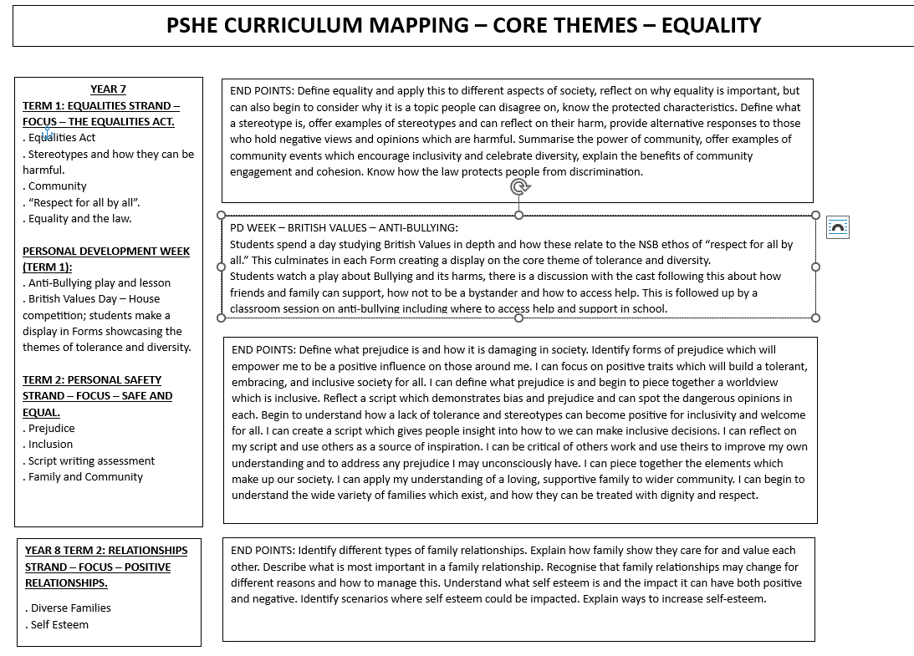
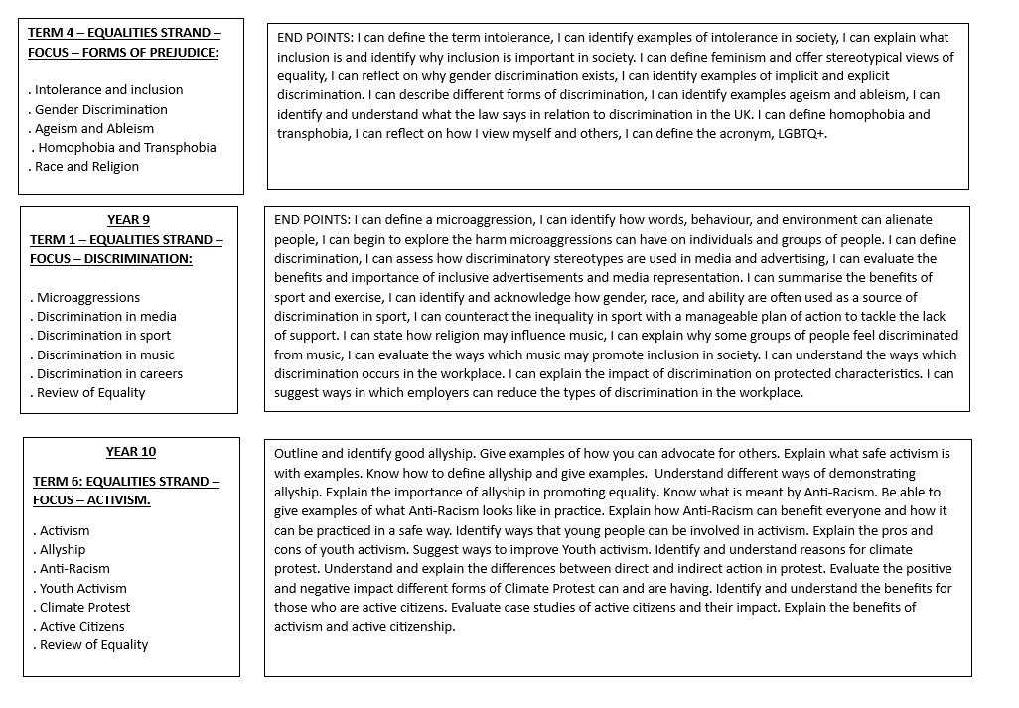
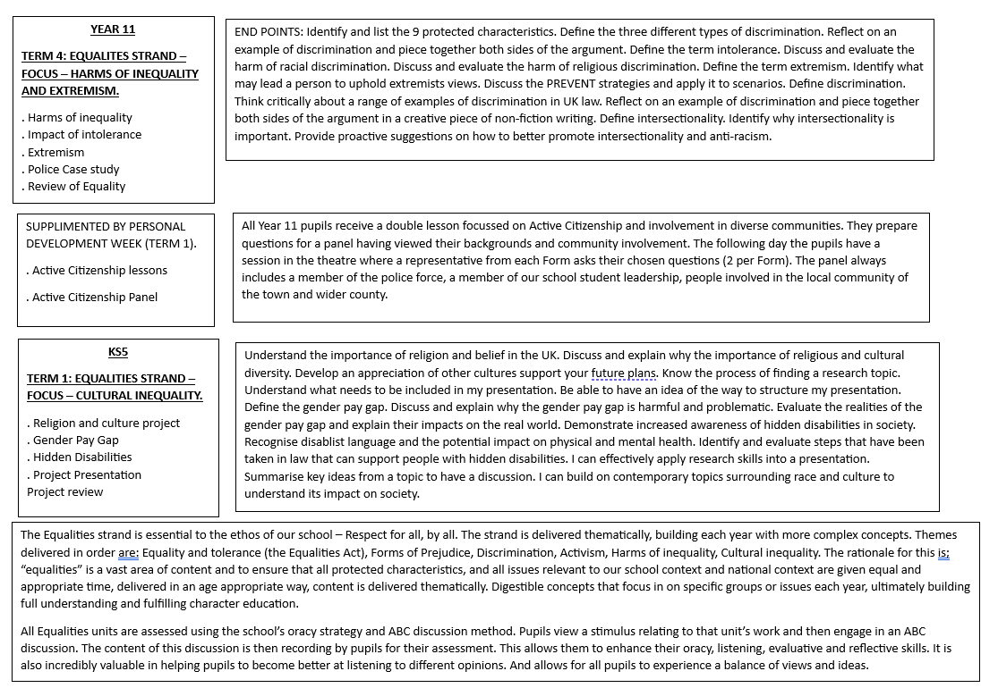

- Morning PD programme
This is now firmly in place with time to address, discuss and reflect on current affairs, citizenship, values and RE as well as an opportunity to engage with reading/literacy. The programme can be adapted easily to address any current issues in school, locally, nationally or internationally. Current Affairs uses Picture News adapted to suit the school (where necessary). Morning PD includes assemblies, led weekly by Year Team Leaders supplemented by guest speakers, assembles from Focus Groups and by peers – Y7 and 8 Forms now take assemblies – Y7 on values and Y8 on role models. This is a highly successful initiative which student their voice and confidence in public speaking. In Y9 this becomes part of their Oracy Lessons alongside debating and a public speaking competition.
The morning PD programme has successfully been broadened to cover a wider range of students and issues to raise awareness and celebrate diversity in our environment and further afield. The list below is not exhaustive:
  - World religion day 3rd Sunday of January
  - Martin Luther King Day 1st January
  - Holocaust Memorial Day 27th January
  - Young Carers Awareness January
  - World Cancer Day 4th Feb
  - International Zero Tolerance for FGM 6th February
  - LGBTQ History Month February
  - Children’s Mental Health Week/Northants Mental Health Awareness day Feb
  - World Languages day
  - International Mother Language Day 21st February
  - International Women’s Day 8th March
  - Women’s History Month March
  - World Autism Awareness Week at school from the 27 March-2 April
  - Stephen Lawrence day 22nd April
  - Mental Health awareness week May8th-14th May
  - Deaf Awareness Week May
  - Idahobit May 17th
  - Carers’ Week 8th – 12th June
  - Learning Disability Week 19th-25th June
  - Dyslexia Awareness Week 2nd – 8th October
  - Dyspraxia Awareness Week 8th-14th October
  - Black History Month October
  - ADHS Awareness Week October
  - World Mental Health Day 10th October
  - Remembrance Day 11th Nov
  - International Men’s Day
  - Anti-bullying week 13th-16th November
  - International Trans Day of Remembrance 20th November
  - International Day for the Elimination of Violence Against Women 25th November
  - Disability History Month Nov/Dec
  - World AIDS Day 1st Dec
  - International Day of Disabled People 3rd Dec
  - Human Rights Day 10th Dec

Equality Objectives 23-24

- A Schoolwide Gender Equality Charter to be created – The Female Lead to facilitate. Staff and students to be consulted. Completed
- SMSC Curriculum Audit to be completed, analysed and evaluated. Completed
- Student Equalities Committee and Wellbeing Committee in place - work on celebrating diversity and identity, highlighting individual characteristics whilst acknowledging and promoting intersectionality and that we can have multiple identities simultaneously, e.g. black, gay and with a disability. (QA curriculum, SMSC Audit, programme of events, PSHE Programme) Completed
- SEND and Mental Health parental newsletters Completed
- Wellbeing fair including LGBTQ+ stands Completed
- Focus on LGBTQ+ - a day for each year group Ongoing

Equality Objectives 24-25

- Staff Voice in line with student voice including termly meetings, surveys and focus groups including wellbeing working party to discuss school issues. Create Staff Wellbeing Offer Completed
- PD Newsletter for staff parents/carers and students
- Equalities day for Year 12 to cover sessions on Gender Equality, Race, Religion, Disability and much more. The idea being that pupils have a full grounding in our Equalities ethos from every perspective and that The Equality Act is there for all individuals. The day will also address those who feel "identity -less" and those who might be economically disadvantaged. Completed
- Programme of role model visits which encompasses the full range of protected characteristics. Ongoing
- Appropriate reporting system for monitoring attendance at extra-curricular activities (over 200 per week running) which can analyse equalities information – protected characteristics as well as PP/LAC/PLAC. Completed
- Neurodiverse Group Focus group to be launched and 6th Form Mentors to supplement the successful mentoring scheme in curriculum subjects, wellbeing mentors and LGBTQ+ mentors. Ongoing
- Improvement to the physical environment to be broadened to take into account wider issues encountered by disabled pupils such as considerations for pupils with autistic spectrum disorders so that they can use recreational spaces - investigate improving the acoustic environment (investigation initially). Ongoing
- Creation of a pupil friendly equality policy by the students whereby senior staff work with pupils through the student council to develop the policy. This will ensure that the language in which the policy is written is accessible for pupils and accurately reflects their understanding of the concepts and issues being discussed and should reflect the way that pupils will experience the school’s commitment to equality including details of:
  - What will be discussed in lessons
  - Programmes of assemblies or speakers
  - Anti-bullying measures
  - Wellbeing
Ongoing
Personal Development Team 2026-27
Assistant Head for Personal Development and Wellbeing and Senior Mental Health Lead - LGR (line manager CAR – Deputy Head)
HKE – Director of PSHE
SJA – Careers Leader
AAB/JHO/NHI – Careers Advisors
TTI - Careers and Work Experience Assistant PD Bursary Holders
CHA - Careers
CCR – Environmental Education FHP – Economic Education
WKN – Safety/Physical Health and Wellbeing
ZAD – Race, Religion/Belief and Discrimination ASC – Gender Equality
RGO- Morning PD Provision for 6th Form
Also liaising with;
ESP and the Inclusion Team in relation to SEND (ESP and JWI (estates) with a responsibility to update the accessibility plan)
IFA and KLA in relation to SEMH/Safeguarding
JBW – Literacy Lead
ABS – Oracy Lead SMR – Debating Society

Equality Objectives 25-27
- Development of the Equalities Committee (by Student Leadership Group and student leader groups) throughout all key stages
- Equality Policy - by students for students
- PD Newsletter for staff parents/carers and students
- Neurodiverse/SEND group to be established
- Programme of role model experiences including staff and external visitors
which encompasses the full range of protected characteristics.
- Update the Gender Equality Charter and change the language around misogyny to multiple, positive masculinities and introduce/promote IMD alongside IWD. Change of branding; The Female Lead to The Gender Forum
- Focus on allyship and further promote positive social action and community
- To provide adapted Careers support, alongside the inclusion team, for students with SEND (GB3) from Y7 regarding guidance, preparation for the world of work and access to events
- House Competitions - analyse data to evaluate uptake and participation, ensuring inclusivity- disadvantaged students/SEND/protected characteristics

