Relationship and Sex
Education (RSE) Policy

To be reviewed annually (to reflect the annual publication of updates from the DfE usually published in September of each year)

Related Policies include Child Protection and Safeguarding Policy, and Behaviour Policy

Contents
1. Aim, rationale and ethos 2
2. Policy development 3
3. Legislation (statutory regulation and guidance) 3
4. RSE definition 4
5. Curriculum design and implication 5
6. Right to withdraw 6
7. Roles and responsibilities 6
8. Effective practice and training 7
9. Safeguarding 7
10. Engaging stakeholders 8
11. Policy review 8
11. Appendix 1: Example curriculum map 9
12. Appendix 2: Example curriculum map 11
13. Appendix 3: Integration of statutory guidance from DfE into RSE (part 1) 12
13. Appendix 3: Integration of statutory guidance from DfE into RSE (part 2) 17
15. Appendix 4: Withdrawal form – examples 26

1. Aim, rationale and ethos
The NSB Trust believes Relationships and Sex education is important for our all students within our Trust as we believe it is important to develop the whole person. Relationships and Sex Education help promote key values that are integral to our ethos; honesty, integrity, humility, perseverance, tolerance, and kindness as well as respect for all by all. We view the partnership of home and school as vital in this.
RSE plays a vital part in meeting each schools’ safeguarding obligations. Ofsted is clear that schools must have a preventative programme that enables students to learn about safety and risks in relationships.
The Trust’s overarching aims for our students are to provide all students with the tools and knowledge they need to be responsible, safe and well-informed citizens who show respect to all, are self-aware and able to seek help for themselves and others when required.
The NSB Trust ensures that all students understand the importance of equality and respect, complying with the relevant provisions of the Equality Act 2010, under which sexual orientation and gender reassignment are amongst the protected characteristics.
More specifically we aim to:
- provide all students with accurate and unbiased knowledge
- provide opportunities for open and accepting discussion; to challenge views, attitudes, and beliefs in order for our students to form their own personal values grounded in respect.
- provide the knowledge and skills needed in order to make safe and informed decisions about their relationships, reproductive health and intimacy.

2. Policy development
This policy covers The NSB Trust’s approach to Relationship, Health and Sex education as part of our wider PHSE provision. This policy has been developed in consultation with identified groups within our staff, students, and parents as well as expert bodies. The consultation and policy development process involved the following steps:
- Review – Trust staff pulled together all relevant information including relevant national and local guidance.
- Staff consultation – all Trust staff were given the opportunity to look at the policy and make recommendations.
- Parent/stakeholder consultation – parents and any interested parties were invited to view the policy online during the consultation phase and contribute their thoughts.
- Student consultation – within each school’s councils and representative bodies to review what exactly students want from their RSE using student voice and working groups.
- Ratification – once amendments were made, the policy was shared with the Trust Board and ratified.

3. Legislation (statutory regulation and guidance)
All schools within the Trust maintain a statutory obligation under the Children Act (2004) to promote their students’ wellbeing and under the Education Act (1996) to prepare student for the challenges, opportunities and responsibilities of adult life. The comprehensive RSE programme developed within the Trust can have a positive impact on students’ health and wellbeing and their ability to achieve and can play a crucial part in meeting these obligations.
Current regulations and guidance from the Department for Education state that all Secondary schools must deliver Relationships and Sex Education as today’s young people are part of an increasingly complex world where they need to know how to be safe and healthy and how to manage their academic, personal, and social lives in a positive way.
The Department of Health set out its ambition for all students to receive high-quality relationships and sex education in the Sexual Health Improvement Framework (2013), while the Department for Education’s paper, The Importance of Teaching (2010) highlighted that ‘Student need high quality relationships and sex education so they can make wise and informed choices’.
We therefore follow the statutory guidance from the Department from Education on Relationships Education, Relationships and Sex Education (RSE) and Health Education and this informs our curriculum and policy. All Secondary Schools within The NSB Trust provide RSE to all students as per section 34 of the Children and Social work act 2017. In teaching RSE, schools are required to have regard to guidance issued by the secretary of state as outlined in section 403 of the Education Act 1996.
The mandatory guidance issued by DfE 2019, and the updated guidance of September 2026, broadened its remit to include non-sexual relationships as well as mental and physical health.
The RSE policy supports/complements other Trust and individual school policies.
Documents that also inform the Trust’s RSE policy include:
- Education Act (1996)
- Learning and Skills Act (2000)
- Children Act (2004)
- Education and Inspections Act (2006)
- Equality Act (2010)
- Sexual Health Improvement Framework (2013)
- Ofsted Report “Not Yet Good Enough: PSHE education in Schools.” (May 2013)
- Children and Social Work Act (2017)
- The Relationships Education, RSE and Health Education (England) Regulations (2019)
- Online Safety Act (2023)
- Relationships Education, Relationships and Sex Education (RSE) and Health Education Statutory Guidance (DfE, 2019, 2026)
- Keeping Children Safe in Education (2025)
The policy will be updated in line with any future revisions to RSHE statutory guidance published by the Department for Education.

4. RSE definition
For the purpose of this policy, and in teaching the curriculum, we define ‘Sex education’ as learning about the physical, social, and emotional aspects of human sexuality and behaviour, including human reproduction. This includes conception and contraception, safer sex, sexually transmitted infections, and sexual health as well as the influence of various media and peer pressure on sexual behaviour.
Aspects of sex education, such as the science of conception are covered in the context of learning about lifecycles as part of the Science curriculum. When learning about infections and their prevention (in Health Education) there may also be reference to sexually transmitted infections. To safeguard students, factual information about the law relating to, for example, rights to access sexual health services, will be provided to students, however specific details regarding prevention and contraception will remain a focus of Sex Education.
Relationship education is defined as learning about the physical, social, legal, and emotional aspects of human relationships including friendships, intimate, sexual and committed relationships and family life. Relationships education supports children to be safe, happy and healthy in their interactions with others now and in the future.
The 2019 guidance (mirrored in the 2026 guidance) states:
“The aim of RSE is to give young people the information they need to help them develop healthy, nurturing relationships of all kinds, not just intimate relationships. It should enable them to know what a healthy relationship looks like and what makes a good friend, a good colleague and a successful marriage or other type of committed relationship. It should also cover contraception, developing intimate relationships and resisting pressure to have sex (and not applying pressure). It should teach what is acceptable and unacceptable behaviour in relationships. This will help students understand the positive effects that good relationships have on their mental wellbeing, identify when relationships are not right and understand how such situations can be managed.”

5. Curriculum design and implication
The NSB Trust RSE programme is an integral part of our whole Trust PSHE education provision. Our RSE programme is inclusive of sexual orientation, disability, diversity, ethnicity, gender identity, culture, age, religion or belief or other life experience. All lessons are taught with respect to the inclusive and diverse nature of our students and each school ethos in line with the Trusts overarching commitment to equality and diversity.
The curriculum is set out as per Appendix 1, this is adapted, when necessary, in line with any
Government recommendations/Statutory Guidance/Local and National priorities as well as individual Trust priorities.
The curriculum has been developed taking into account the age, needs and feelings of students to ensure an age appropriate and compassionate curriculum. If students ask questions outside the scope of this policy, teachers will respond in an appropriate manner, with unbiased, factual information, so that they are fully informed and able to seek additional information from reliable and appropriate sources outside of the classroom should they wish. The Trust also utilises outside speakers, the assembly framework and Personal Development Form sessions to support this delivery.
RSE is taught within the personal, social, health and economic (PSHE) education curriculum. Within the curriculum there are seven thematic areas of focus: Health and Wellbeing, Equalities, Financial Wellbeing, Environmental Education, Personal Safety, Careers and Relationships. RSE is taught in the Relationships strand (See Appendix 2 for example curriculum maps).
Each of these themes are taught within the context of family life, taking care to ensure that there is no stigmatisation of children based on their home circumstances (families can include single parent families, LGBTQ parents, families headed by grandparents, adoptive parents, foster parents/carers amongst other structures) along with reflecting sensitively that some children may have a different structure of support around them (for example: looked after children or young carers) as well as cultural sensitivity.
How this education is provided:
RSE is co-ordinated by the PSHE Lead and the Assistant Headteacher responsible for Personal Development in each school and is taught with the PSHE programme for Key Stages 3, 4 and 5. Some of the biological aspects of RSE surrounding sex and intimacy such as Conception are taught within the Science curriculum. Some moral issues and aspects relating to marriage are taught within RE. RSE within PSHE is taught by specialist PSHE teaching staff who are provided with internal face to face training and ongoing CPD throughout an academic year . Consultation on the content of these sessions will take place between the PSHE Lead, relevant Assistant Headteachers of each school, Pastoral leaders, Senior Leadership and student leadership.
Those students who would benefit from a differentiated and bespoke programme of study will be identified through discussion with the SENDCo, Inclusion Teams and Pastoral leaders, and parents. Delivery will be given by trained staff if appropriate. All RSE teaching is expected to reflect the values and attitudes laid out by this document. All RSE deliverers will be expected to have read and adhere to all aspects of the programme of study and its content, irrespective of personal opinion or belief.
For information regarding curriculum compliance with statutory guidance, please see the appendices.

6. Right to withdraw
According to DfE guidelines, Parents and Carers have the right to withdraw their children from some or all parts of Sex Education delivered within RSE. All students, three terms before they turn 16 have the right to choose if they wish to receive Sex Education and, therefore can opt back in if they have previously been withdrawn.
The details of which lessons within RSE are classed as Sex Education can be found in Appendix 2 and 5 (Withdrawal request form) and on our website’s PSHE Parent and Carer Guidance section.
Any request for withdrawal will be followed by a meeting with the relevant person within a Trust school’s Senior Leadership Team. Should Parents/Carers wish to proceed with a withdrawal from Sex Education, they will need to indicate which lessons specifically they wish to withdraw their child from on the Withdrawal Form (Appendix 5) and give written explanation for withdrawal. A copy of withdrawal requests will be placed in the student’s educational record.
All students who are withdrawn from Sex Education will receive alternative PSHE education during those lessons.

7. Roles and responsibilities
The Trust Board will approve the RSE policy and hold the Executive Headteacher to account for its implementation.
Governors and Trustees
As part of their obligation Trust Board and Local Committees in each school must make sure that RSE and PSHE is well structured, funded, and taught in line with national statutory guidance to enable each school to fulfil its statutory obligations. They must ensure that clear information is provided for parents on the subject content and the right to request that their child is withdrawn; and that teaching is accessible to all students inclusive of those with SEND.
Executive Headteacher/Headteacher
The Executive Headteacher is responsible for ensuring that consistency exists in implementation across The NSB Trust. This will involve part of the Executive Team and associated Leaders within schools.
The Headteacher of individual Trust schools - The Headteacher is responsible for ensuring that RSE is taught consistently within their school, and for managing requests to withdraw students from Sex Education. This communication is managed initially through the relevant person within the Senior Leadership Team.
PSHE Lead within each school
The PSHE lead is responsible for creating and updating annually an age-appropriate, spiral curriculum based on the Trust RSE Policy, that is fit for purpose following the guidelines of the DfE with consideration for the individual contexts and needs of the students within each school. They will, along with the relevant members of staff, reflect on provision using relevant feedback from across each school community and adapt accordingly. They will also facilitate training for all relevant staff. In addition, they will conduct Quality Assurance of the delivery of the curriculum, reflect on this with relevant members of the Senior Leadership Team and the PSHE department, and use this data to inform training and curriculum development.
Pastoral Management Team
The Pastoral Management Team of each school and Senior Leadership Team oversee the delivery of RSE. And the wider team are kept up to date on the curriculum at regular meetings where school and Trust priorities can be identified.
Staff
Across Key Stages PSHE is delivered by a specialist team who receive a bespoke training programme throughout each academic year as well as attending regular team meetings. The entire team focusses on; delivering RSE in an informed and sensitive way, modelling positive attitudes to RSE, monitoring, recording, and assessing progress, responding to the needs of individual students, and responding appropriately to students whose parents/carers wish them to be withdrawn from Sex Education. All staff should also be well versed in the Trust RSE Policy. Staff who have concerns about teaching specific aspects of RSE are encouraged, in the first instance, to discuss this with the headteacher’s designated Senior Leadership Team member responsible for Personal Development (which incorporates RSE) or the PSHE Lead of their school.

8. Effective practice and training
In order to ensure the highest level of provision year on year, the PSHE Lead of each school, Assistant Head teacher in charge of Personal Development and other relevant staff will meet to continually reflect on practice, curriculum content and quality assurance.
Teaching staff will receive high-quality training on the entire PSHE curriculum content and delivery, and more specific training on RSE during designated Staff Training days, and throughout the year in order to support both staff and students.
RSE is inclusive and meets the needs of all our students, including those with special educational needs and disabilities (SEND) by providing high quality lessons that are accessible to all students by specially trained staff, with the offer of additional support materials and in person sessions focussed on RSE for parents of those student with particular needs, such as social and communication difficulties, for example, ASD, provided in consultation with our Additional Intervention Team. See above on how RSE is delivered.

9. Safeguarding
As a Trust we are aware that effective RSE, which brings an understanding of what is and what is not appropriate in a relationship, can lead to a disclosure of child protection issues. Should any member of staff experience this or be unsure if they have had something disclosed to them, they should refer to Section 9 of the Trust’s Child Protection Policy for guidance.
Confidentiality
If a student makes a personal disclosure to a member of staff, that member of staff cannot offer or guarantee unconditional confidentiality. The procedure set out in The NSB Trust Child Protection Policy for when a child reveals abuse should be used in these circumstances.
Processes and procedures following a disclosure will follow the pathway and guidance provided in the Child Protection Policy.

10. Engaging stakeholders
We aim to work closely with parents/carers to ensure that they are fully aware of what is being taught and provide additional resources and support through the PSHE section of each school’s website. Our policies can also be accessed via each school’s website.
As part the Trust’s approach to RSE, Parent/Carer Information sessions and opportunities for parents/carers to view the materials and resources used will be available online via each school’s website as well as upon request.
Students will have the opportunity to give feedback on RSE through student voice exercises as part of the Trust’s House System and School Councils. This feedback will be presented to the PSHE Team for consideration when reflecting upon the provision.

11. Policy review
This policy will be updated, as necessary, annually by the relevant staff within the Trust who will ensure that it is reviewed by the Trust Board. At every review, any changes to the policy will be approved before being acted upon.

11. Appendix 1: Example curriculum map
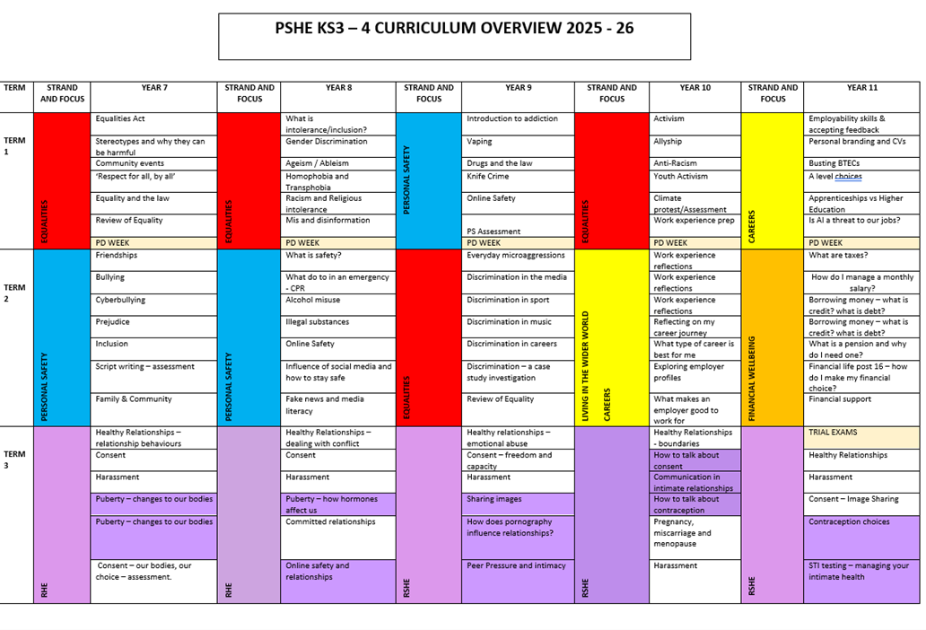
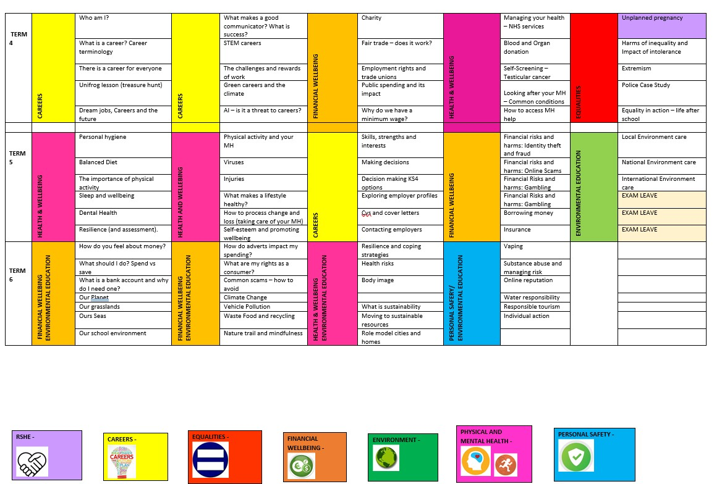

12. Appendix 2: Example curriculum map
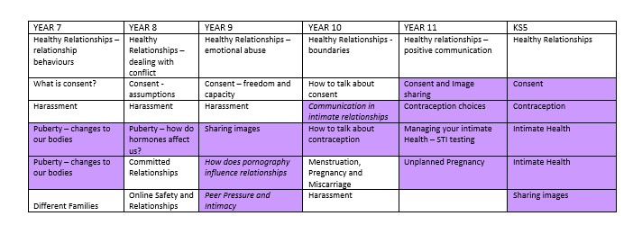

13. Appendix 3: Integration of statutory guidance from DfE into RSE (part 1)
Content | Theme | Year group covered
How to talk about emotions accurately and sensitively, using appropriate vocab | MH &wellbeing | Year 7 - Resilience Strategies PD Week, Mental Health and wellbeing, Healthy relationships  Year 8 – Puberty – our changing feelings, Healthy relationships  Year 9 – Coping with stress – school/life balance, Healthy Relationships  Year 10 – Managing stress – GCSE, Diet, Sleep, Exercise for wellbeing, Common MH conditions MH – how to access help, Healthy relationships.  Year 11 – Mental Health – how to seek help PD Week, Healthy relationships
Happiness is linked to being connected to others | MH & Wellbeing | Year 7 – Family and Community, Healthy Relationships, British Values Day PD Week, Committed relationships – marriage and civil partnership  Years 8 – Healthy Relationships, Diverse families and relationships, how to process change and loss  Year 9 – Healthy relationships, PD Week Expressive Arts Project  Year 10 – Healthy relationships, Blood and organ donation,  Year 11 – Healthy relationships, Mental Health PD Week
How to recognise the early signs of mental wellbeing concerns. | MH & Wellbeing | Year 7 - Resilience strategies PD week, Sleep, and wellbeing, Wellbeing Helping others  Year 8 - Physical activity and Mental Health  Year 9 – Coping with Stress – school/life balance  Year 10 - Managing stress – GCSE, Diet, Sleep, Exercise for wellbeing, Common MH conditions MH – how to access help  Year 11 – Mental Health – how to seek help PD Week, Healthy relationships
Common types of mental ill health | MH & Wellbeing | Year 9 – Coping with stress – school/life balance  Year 10 – Managing stress – GCSE, Diet, Sleep, Exercise for wellbeing, Common MH conditions MH – how to access help  Year 11 – Mental Health PD Week
How to critically evaluate when something they do or are involved in has a positive or negative effect on their own or others’ MH | MH & Wellbeing | Year 7 – Healthy Relationships, Stereotypes and why they can be harmful, Friendships, Bullying  Cyberbullying, Prejudice, Inclusion. Family and Community  Year 8 – Online Safety, Influence of social media and how to stay safe, Puberty – our changing feelings, Healthy  Relationships  Year 9 – Healthy Relationships, Resilience, coping with stress – school/life balance, Gender expression and identity, Gender based discrimination – microaggressions and society, Disability Discrimination – How disability discrimination looks in the wider world, Age Discrimination – How does ageism look in the world,  Year 10 – Managing stress – GCSE, Diet, Sleep, Exercise for wellbeing, Common MH conditions  MH – how to access help, Allyship, Healthy Relationships  Year 11 – Healthy Relationships, Mental Health PD Week, Allyship, Anti-Racism, Harms of extremism.

The benefits and importance of physical exercise, time outdoors, community participation and voluntary and service – based activities on MH & wellbeing | MH & Wellbeing | Year 7 – The importance of physical activity, Wellbeing – helping others, Family and Community, British Values Day PD Week  Year 8 - Influences on lifestyle, Physical activity and Mental Health, Nature trail and mindfulness  Year 9 – Fairtrade and ethical spending, Work Experience, Health risks and being responsible for your own health  Year 10 – Responsible tourism, Conscientious customer, Work Experience, Allyship  Year 11 – Masculinity, Allyship, Anti-Racism, Community Citizenship Forum PD Week
Similarities and differences between the online world and the physical world, including – the impact of unhealthy or obsessive comparison with others online (inc. body image), how people may curate a specific image of their life online, over-reliance on online relationships including social media, the risks related to online gambling including accumulation of debt, how advertising and information is targeted at them and hoe to be a discerning consumer of information online. | Internet safety and harms | Year 7 – Friendships, Bullying, Cyberbullying, Online/offline relationships, Body Image, and Identity Gender  Equality Day  Year 8 – Online Safety, Influence of social media and how to stay safe, Body Image and Identity Gender  Equality Day  Year 9 – Managing risk and gambling, Fake emails and phishing, Body image and its impact on relationships, Online Safety  Year 10 – Body image Gender Equality Day, Race and Religion: Fake-news and radicalisation,  Year 11 – Online safety, social media, and employment, Investments - Cryptocurrency and NFTs  Financial safety - fraud and money mules, Borrowing money - manageable and unmanageable debt, Consent – image sharing
How to identify harmful behaviours online (including bullying, abuse, or harassment and how to report or find support, if they have been affected by those behaviours. | Internet safety and harms | Year 7 –Cyberbullying, On/offline relationships, Harassment  Year 8 – Online safety, Influence of social media on behaviour, On/offline relationships, Harassment  Year 9 –Harassment, Online Safety, Sharing images, Influence of pornography on relationships Year 10 – social media and employability, Harassment, Online life balance, Year 11 – Harassment
The positive associations between physical activity and promotion of mental wellbeing, including as an approach to combat stress. | Physical health and fitness | Year 7 – Resilience Strategies PD Week, Mental Health and wellbeing, Healthy relationships, the importance of physical activity, Wellbeing – helping others,  Year 8 – Influences on lifestyle, Physical activity, and Mental Health  Year 9 – Resilience, Coping with stress – school/life balance  Year 10 – Diet, Sleep, Exercise for wellbeing, MH – how to access help,  Year 11 – Mental Health PD Week, Nutrition and Study PD Week
The characteristics and evidence of what constitutes a healthy lifestyle, maintain a healthy weight, including the links between an inactive lifestyle and ill health, including cancer and cardio-vascular ill-health. | Physical health and fitness | Year 7 – Balanced diet, The importance of physical activity, Sleep and wellbeing, Dental Health  Year 8 – Influences on lifestyle, Physical activity, and Mental Health  Year 9 – Health risks and being responsible for your own health  Year 10 – Risks of substances, Lifestyle choices, Using the NHS, Blood and organ donation  Prevention of major health conditions inc. self-screening  Year 11 – Oddballs self-screening PD Week
The science relating to blood, organ, and stem cell donation | Physical health and fitness | Year 10 – Risks of substances, Lifestyle choices, Using the NHS, Blood, and organ donation Prevention of major health conditions inc. self-screening

 |  |  | Year 11 – Oddballs self-screening PD Week
How to maintain healthy eating and the links between a poor diet and health risks, including tooth decay and cancer. | Healthy eating |  | Year 7 – Balanced diet, The importance of physical activity  Year 8 - Influences on lifestyle, Physical activity, and Mental Health  Year 9 - Health risks and being responsible for your own health  Year 10 - Lifestyle choices  Year 11 – Nutrition PD Week
The facts about legal and illegal drugs and their associated risks, including the link between drug use, and the associated risks, including the link to serious mental health conditions. | Drugs, alcohol, tobacco | and | Year 8 – Alcohol Misuse, Illegal substances  Year 9 - Drugs and the Law  Year 10 - Risks of substances, Lifestyle choices  Year 11 – Hope UK programme PD Week
The law relating to the supply and possession of illegal substances. | Drugs, alcohol, tobacco | and | As above
The physical and psychological risks associated with alcohol consumption and what constitutes low risk alcohol consumption in adulthood. | Drugs, alcohol, tobacco | and | As above
The physical and psychological consequences of addition, including alcohol dependency. | Drugs, alcohol, tobacco | and | As above
Awareness of the dangers of drugs which are prescribed but still present serious health risks. | Drugs, alcohol, tobacco | and | As above
The facts about the harms from smoking tobacco (particularly to lung cancer), the benefits of quitting and how to access support to do so. | Drugs, alcohol, tobacco | and | As above
Personal hygiene, germs including bacteria, viruses, how they are spread, treatment and prevention of infection and about antibiotics. | Health and prevention |  | Year 7 – Personal Hygiene  Year 8 – Viruses  Year 9 - Health risks and being responsible for your own health  Year 10 - Lifestyle choices, Using the NHS
Dental health and the benefits of good oral hygiene and dental flossing including healthy eating and regular check-ups at the dentist. | Health and prevention |  | Year 7 - Personal Hygiene, Dental Health  Year 9 - Health risks and being responsible for your own health  Year 10 - Lifestyle choices, Using the NHS
The benefits of regular self-examination and screening. | Health and prevention |  | Year 9 - Health risks and being responsible for your own health  Year 10 - Lifestyle choices, Using the NHS, Blood and organ donation, Prevention of major health conditions inc. self-screening  Year 11 – Oddballs Self Screening PD Week
The facts and science relating to immunisation and vaccination | Health and prevention |  | Year 9 - Health risks and being responsible for your own health  Year 10 - Lifestyle choices, Using the NHS, Prevention of major health conditions inc. self-screening
The importance of sufficient good quality sleep for good health and howe a lack of sleep can affect weight, mood, and ability to learn. | Health and prevention |  | Year 7 – Sleep and wellbeing  Year 9 - Coping with stress – school/life balance, Health risks and being responsible for your own health Year 10 - Lifestyle choices, Managing stress – GCSE, Diet, Sleep, Exercise for wellbeing
Basic treatment of common injuries | Basic First Aid |  | Year 8 - First Aid – CPR, Viruses, Injuries Year 10 - Emergency responses
Life-saving skills, including how to administer CPR | Basic First Aid |  | As above
The purpose of defibrillators and when one might be needed. | Basic First Aid |  | As above
Key facts about puberty, the changing adolescent body and menstrual wellbeing | Changing adolescent body |  | Year 7 – Puberty – changes to our bodies  Year 8 - Puberty – our changing feelings  Year 10 – Pregnancy, miscarriage, and periods
The main changes which take place in males and females and the implications for emotional and physical health. | Changing adolescent body |  | Year 7 – Puberty – changes to our bodies  Year 8 – Puberty – our changing feelings  Year 10 - Pregnancy and miscarriage, Lifestyle choices and reproductive health

13. Appendix 3: Integration of statutory guidance from DfE into RSE (part 2)

Content | Theme | Year group covered and lessons
That there are different types of committed, stable relationships | Families | Year 7 – Equalities Act, Stereotypes and why they can be harmful, Family and Community, Committed relationships – marriage and civil partnership  Year 8 - Diverse families and relationships  Year 9 – Healthy Relationships  Year 10 – Healthy Relationships Year 11 – Healthy Relationships
How these relationships might contribute to human happiness and their importance in bringing up children. | Families | As above
What marriage is, including their legal status e.g., that marriage carries legal rights and protections not available to couples who are cohabiting or who have married, for example in an unregistered religious ceremony. | Families | As above
Why marriage is an important relationship choice for many couples and why it must be freely entered into. | Families | As above and in addition:  Forced Marriage – Year 11
The characteristics and legal status of other types of long-term relationships | Families | As above excluding forced marriage.

The roles and responsibilities of parents with respect to raising of children, including the characteristics of successful parenting. | Families | As above and in addition:  Domestic abuse, exploitation and how to seek help – Year 11
How to: determine whether other children, adults, or sources of information are trustworthy: judge when a family, friend, intimate relationship is unsafe (and to recognise this in others’ relationships); and, how to seek help or advice, including reporting concerns about others, if needed. | Families | Years 7 – 11: Healthy relationships
The characteristics of positive and healthy friendships (in all contexts, including online) including trust, respect, honesty, kindness, generosity, boundaries, privacy, consent and the management of conflict, reconciliation and ending relationships. This includes different (non-sexual) types of relationship. | Respectful  relationships, including friendships | As above and in addition:  Year 7 – Online/offline relationships, Committed relationships – marriage and civil partnership, Friendships, Bullying, Cyberbullying, Resilience PD week, Harassment, Consent  Year 8 - How to process change and loss, Harassment, Consent, Online Safety, Influence of social media and how to stay safe  Year 9 – Harassment, Consent, Online Safety  Year 10 – Harassment, Consent, Sexting and Revenge porn  Year 11 – Harassment, Consent – image sharing, Domestic abuse, exploitation and how to seek help
Practical steps they can take in a range of different contexts to improve or support respectful relationships. | Respectful  relationships, including friendships | As above
How stereotypes, in particular stereotypes based on sex, gender, race, religion, sexual orientation, or disability, can cause damage (e.g., how they might | Respectful  relationships, including friendships | Year 7 – Equalities Act, Stereotypes and why they can be harmful, Inequality, Disability Discrimination – What is Disability? Age Discrimination – How is age treated differently?

normalise non-consensual behaviour or encourage prejudice). |  | Year 8 - Expression of gender/autonomy, Domestic inequality – stereotypes, Sexuality based discrimination, Race, and religion – What is racism? Race and Religion – Mis/disinformation.  Year 9 - History of Feminism, Gender expression and identity, Gender based discrimination – microaggressions and society, Disability Discrimination – How disability discrimination looks in the wider world, Age Discrimination – How does ageism look in the world.  Year 10 - Case study – ABC – SE &SN, Gender identity, Allyship, Race and religion: Impact of Racism, Race and Religion: Fake-news and radicalisation  Year 11 - Case study – equality in sport, Masculinity, Allyship, Anti-Racism, Harms of extremism.
That in school and in wider society they can expect to be treated with respect by others, and that in turn they should show due respect to others, including people in positions of authority and due tolerance of other people’s beliefs. | Respectful  relationships, including friendships | As above
Different types of bullying (including cyber bullying), the impact of bullying, responsibilities of bystanders to report bullying and how and where to get help. | Respectful  relationships, including friendships | Year 7 – What is bullying, Cyber bullying, Harassment, Anti-bullying week  Year 8 – Anti-bullying week, online safety  Year 9 – Anti-Bullying week, On/offline world, online risks, Harassment  Year 10 – Anti-Bullying week, Harassment  Year 11 – Anti – bullying week, Harassment
That some types of behaviour within relationships are criminal, including violent behaviour and coercive control. | Respectful  relationships, including friendships | Year 7 – Healthy relationships, Consent, Harassment  Year 8 – Healthy relationships, Consent, Harassment  Year 9 – Healthy relationships, Consent, Harassment  Year 10 – Healthy relationships vs Exploitative/Coercive, Relationship myths, Harassment  Year 11 – Harassment, Healthy relationships, Consent

What constitutes sexual harassment and sexual violence and why these are always unacceptable. | Respectful  relationships, including friendships | As above
The legal rights and responsibilities regarding equality (particularly with reference to protected characteristics as defined in the Equality Act 2010) and that everyone is unique and equal. | Respectful  relationships, including friendships | Year 7 – Equalities Act, Stereotypes and why they can be harmful, Inequality, Disability Discrimination – What is Disability? Age Discrimination – How is age treated differently?  Year 8 - Expression of gender/autonomy, Domestic inequality – stereotypes, Sexuality based discrimination, Race, and religion – What is racism? Race and Religion – Mis/disinformation.  Year 9 - History of Feminism, Gender expression and identity, Gender based discrimination – microaggressions and society, Disability Discrimination – How disability discrimination looks in the wider world, Age Discrimination – How does ageism look in the world.  Year 10 - Case study – ABC – SE &SN, Gender identity, Allyship, Race and religion: Impact of Racism, Race and Religion: Fake-news and radicalisation  Year 11 - Case study – equality in sport, Masculinity, Allyship, Anti-Racism, Harms of extremism.
Their rights and responsibilities and opportunities online, including that the same expectations of behaviour apply in all contexts, including online. | Online and Media | Year 7 – Cyberbullying  Year 8 – Online Safety, Influence of social media and how to stay safe  Year 9 – Online Safety  Year 10 - social media and Employability  Year 11 – Image sharing Consent
Online risks, including that any material someone provides to another has the potential to be shared online and the difficulty of removing potentially compromising material placed online. | Online and Media | As above

Not to provide material to others that they would not want shared further and not to share personal material which is sent to them. | Online and Media | As above and in addition –  Healthy relationships (all years)
What to do and where to get support to report material or manage issues online | Online and Media | As above
The impact of viewing harmful content | Online and Media | As above and in addition:  Year 9 – How does the media and pornography influence relationships? Year 10 – Revenge porn
That specifically sexually explicit material e.g., pornography presents a distorted picture of sexual behaviours, can damage the way people see themselves in relation to others and negatively affect how they behave towards sexual partners. | Online and Media | As above
That sharing and viewing indecent images of children (including those created by children) is a criminal offence which carries severe penalties including jail. | Online and Media | Year 7 – Consent, Staying safe online  Year 8 – Consent, Online Safety, On/offline relationships  Year 9 – Peer pressure and sexual activity, Online safety  Year 10 – Healthy vs Exploitative/Coercive relationships, how to manage the end of relationships  Year 11 – Consent and Image Sharing, Healthy relationships
How information and date is generated, collected, shared, and used online. | Online and Media | Year 7 – Staying safe online  Year 8 – Online safety  Year 9 – Online Safety  Year 10 – social media and Employability

 |  |  | Year 11 – Consent and image sharing
The concepts of, and laws, relating to, sexual consent, sexual exploitation, abuse, grooming, coercion, harassment, rape, domestic abuse, forced marriage, honour-based violence and FGM, and how these can affect current and future relationships. | Being Safe |  | Year 7 – Harassment, Consent, Healthy relationships  Year 8 – Healthy relationships, Consent, Harassment  Year 9 – Healthy relationships, Consent, Harassment, FGM and forced marriage  Year 10 – Healthy Relationships, Consent, Harassment  Year 11 – Healthy Relationships, Consent, Harassment
How people can actively communicate and recognise consent from others, including sexual consent, and howe and when consent can be withdrawn (in all contexts, including online). | Being Safe |  | As above and in addition:  Year 7 – On/Offline relationships  Year 8 – Online safety  Year 9 – Online Safety  Year 10 – Contraception and consent  Year 11 – Consent and Image Sharing
How to recognise the characteristics and positive aspect of healthy one-to-one intimate relationships, which include mutual respect, consent, loyalty, trust, shared interests and outlook, sex and friendship. | Intimate and sexual relationships, including sexual healthy |  | Year 7 – 11: Healthy relationships
That all aspects of health can be affected by choices they make in sex and relationships, positively or negatively, e.g., physical, emotional, mental, sexual, and reproductive health and wellbeing. | Intimate and sexual relationships, including sexual healthy |  | Year 7 – Consent  Year 8 – Consent  Year 9 – Consent, Peer pressure and sexual activity  Year 10 – Contraception choices, Consent, how to manage the end of relationships, Consent and contraception, Reproductive health Year 11 – Image sharing, Consent

The facts about reproductive health, including fertility, and the potential impact of lifestyle on fertility for men and women and menopause. | Intimate and sexual relationships, including sexual healthy | Year 7 – Puberty – changing bodies  Year 8 – Puberty – changing feelings  Year 10 – Pregnancy and miscarriage, Lifestyle choices and reproductive health
That there are a range of strategies for identifying and managing sexual pressure, including understanding peer pressure, resisting pressure, and not pressurising others. | Intimate and sexual relationships, including sexual healthy | Year 7 – Consent, Healthy relationships  Year 8 – Consent, Healthy relationships  Year 9 – Peer pressure and sexual activity, how does the media and pornography influence relationships? Healthy relationships  Year 10 – Healthy relationships  Year 11 – Consent, Healthy relationships
That they have a choice to delay sex or to enjoy intimacy without sex | Intimate and sexual relationships, including sexual healthy | As above
The facts about the full range of contraceptive choices, efficacy, and options available. | Intimate and sexual relationships, including sexual healthy | Year 9 – Contraception and STI risk  Year 10 - Contraception and STI risk  Year 11 - Pregnancy – what to do, Contraception and STIs – where to access help
The facts around pregnancy and miscarriage | Intimate and sexual relationships, including sexual healthy | Year 10 - Pregnancy miscarriage and pregnancy options including young parenthood  Year 11 – Contraception, STIs, Pregnancy and choices around intimacy
That there are choices in relation to pregnancy (with medically and legally accurate, impartial information on all options, including keeping the baby, adoption, abortion and where to get further help). | Intimate and sexual relationships, including sexual healthy | As above
How the different sexually transmitted infections (STIs), including HIV/AIDS, are transmitted, how risk can be reduced through safer sex (including through condom use) and the importance of and facts about testing. | Intimate and sexual relationships, including sexual healthy | Year 9 - Understanding contraception, STI’s and risk  Year 10 – Contraception choices, STIs  Year 11 – Contraception, STIs, Pregnancy and choices around intimacy
The prevalence of some STIs, the impact they can have on those who contract them and key facts about treatment |  | As above
How the use of alcohol and drugs can lead to risky sexual behaviour | Intimate and sexual relationships, including sexual healthy | Year 10 - Risks of substances, Lifestyle choices  Year 11 – Hope UK programme PD Week
How to get further advice, including how and where to access confidential sexual and reproductive health advice and treatment. | Intimate and sexual relationships, including sexual healthy | Year 9 – Peer pressure and choices about sexual activity, Contraception and STI risk  Year 10 - Contraception and STI risk  Year 11 - Pregnancy – what to do, Contraception and STIs – where to access help

15. Appendix 4: Withdrawal form – examples

Student name and Form:
Lessons to be withdrawn from, please indicate:
Puberty - changes to our bodies (this lesson focuses on the physical changes that happen to the male body during puberty).

Puberty – changes to our bodies (this lesson focuses on the physical changes that happen to the female body during puberty).

Reasons for withdrawal from these lessons, please be specific:
Signed: | Date: | Print Name:

Student name and Form:
Lessons to be withdrawn from, please indicate:
Puberty – how hormones affect us (this lesson focusses on hormonal changes during puberty and how they can impact emotions, including new feelings such as physical attraction).

Online safety and relationships (this lesson focusses on protecting yourself online and how to seek help).

Reasons for withdrawal from these lessons, please be specific:
Signed: | Date: | Print Name:

Student name and Form:
Lessons to be withdrawn from, please indicate:
Sharing images (this lesson focusses on why people might share images or ask for images, and the risks involved).

How does the media and pornography influence relationships and intimacy? (this lesson focusses on the unhealthy relationship and intimate expectations that different media can place on intimacy).

Peer Pressure and intimacy (this lesson focusses on how peer pressure can impact feelings around intimacy and how to combat that pressure).

Reasons for withdrawal from these lessons, please be specific:
Signed: | Date: | Print Name:

Student name and Form:
Lessons to be withdrawn from, please indicate:
How to talk about consent (this lesson focusses on how to have conversations about consent, language that can be used and emotional considerations).

Communication in intimate relationships (this lesson focusses on positive communication vs negative communication in intimate relationships).

How to talk about contraception (this lesson focusses on different forms of contraception and how to have conversations about this with doctors, partners etc).

Reasons for withdrawal from these lessons, please be specific:
Signed: | Date: | Print Name:

Student name and Form:
Lessons to be withdrawn from, please indicate:
Contraception choices (this lesson focusses on different forms of contraception, pros and cons and how to make informed choices).

Managing your intimate health – STIs (this lesson focusses on how to manage intimate health using health services, including knowledge of STIs and how to access prevention and treatment).

Unplanned Pregnancy (this lesson focusses on options for young people in the event of an unplanned pregnancy including, young parenthood and help available, adoption and termination).

Reasons for withdrawal from these lessons, please be specific:
Signed: | Date: | Print Name:

