Work Experience Journal
This journal will help you plan and track your work experience. You’ll need to fill in some sections before, during, and after your work experience.

A) COMPLETE BEFORE PLACEMENT
- Work experience profile
Complete the following sections:
Dates of experience:
Start date: | End date:
Working hours:
From: | To:
Things to prepare:
Lunchtime arrangements (e.g. packed lunch, provided by work, buying lunch yourself)
Workwear (e.g. are you required to wear particular clothing such as a suit, high visibility jacket, company clothing, or a uniform?)

Will this be provided for you? Yes / No

Travel arrangements:
Mode of travel (e.g. car, train, walk, bus) |  | Journey length | Cost of travel
Main contact:
Write the name of the person you are reporting to during your work experience:
- Protocols
What will I do if…
I wake up and feel too unwell to go to work? | I realise that I’m going to be late? | I’m concerned about part of my work experience?
- Health and safety
Sign names:  A) Danger: Obstacles  B) Emergency exit  C) No smoking  D) Fire extinguisher  E) First aid  F) No naked flames  G) Safety boots must be worn  H) Safety helmet must be worn  I) Eye protection must be worn  J) No access for pedestrians  K) Danger: Flammable material  L) Danger: Electricity | Match the health and safety sign name to the graphic:
 |  |  | 
 | 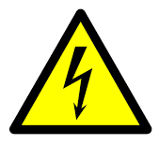 | 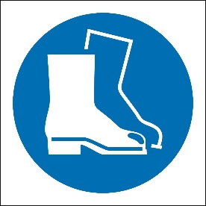 | 
 |  | 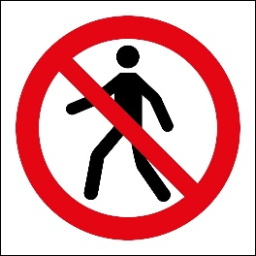 | 
 | 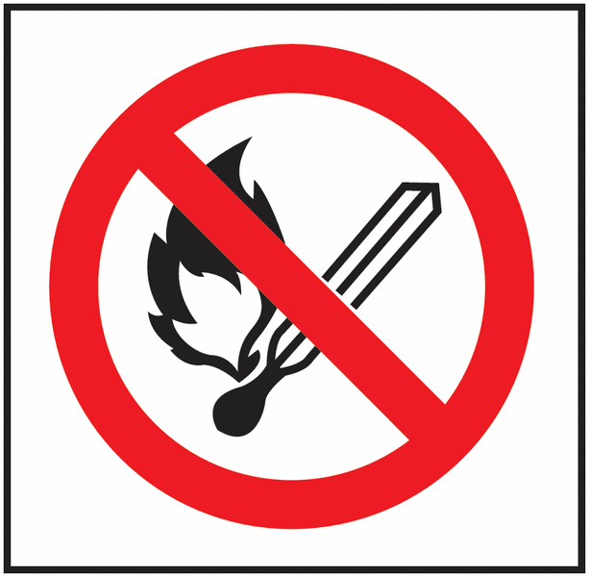 | 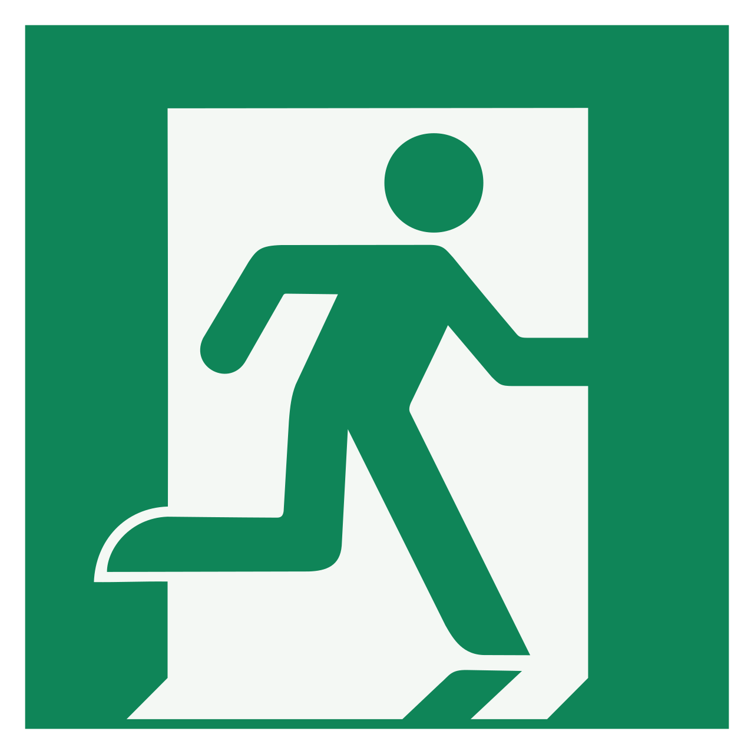 | 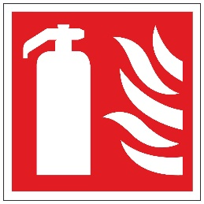
Who should you talk to if you see a health and safety risk while on work experience?
Remember: You will be informed of any health and safety rules you must adhere to at work.
You must inform your employer of any medical conditions or health issues you may have, especially if they could affect your ability to undertake certain tasks.
- Outcomes of your work experience
Overall, write down the main thing you hope to achieve from your work experience:
Write down three things you’ll do to make the most of your work experience:
Write down three key skills you would like to develop during your work experience:
Who can help you to achieve your goals during your work experience?

B) COMPLETE DURING WORK EXPERIENCE
- Daily log
Complete each of the suggested tasks each day of your work experience.
Day one: What did you do?
Who did you meet? What was their job title or role? | Who do you work with directly? What is their job title or role?
Write at least one thing that went well today. | Write at least one thing you are looking forward to about tomorrow.
Day two: What are your tasks?
Explain at least one task you did today. Provide as much detail as possible. | Did you enjoy completing this task? Explain your answer.
Day three: Mid-week reflection
Write down one thing that’s gone well so far this week. | Write down one thing that you still want to explore/learn about this week?
Day four: What is your place of work like?
Describe what your workplace is like. Provide as much detail as possible. | Is this type of workplace suited to you?  Explain your answer.
Day five: What did you learn?
Write down three things you learned this week.  - 1.  - 2.  - 3. | Who has had the most impact on your time with the organisation this week? Why? (think about their qualities as a colleague)

- Interview with employees
Complete this interview template with two employees with different job roles.
Employee interview one | Employee interview two
1. What is your job role?
2. What are your main responsibilities?
3. What qualifications or training did you need for your job?
4. How long have you been in your job role?
5. What was the application process required for your job role?
6. What are the key skills required for your job?
7. What initially interested you in this role?
8. What is the best part of your job?
9. What is the most challenging part of your job?
10. What advice would you give to someone wanting to get into your industry?
C) COMPLETE AFTER WORK EXPERIENCE
Work experience summary
  - Did you manage to achieve the goal you set before your work experience? Explain your answer.
  - Did you do the three things you planned to do to make the most of your work experience?
Explain your answer.
  - Did you develop the three skills you wanted to improve during your work experience?
Add at least one skill onto Unifrog using the Skills tool.
- Did you gain any additional skills you didn’t expect to develop during your work experience?
Add at least one skill onto Unifrog using the Skills tool.
- What was your favourite thing about work experience?
Explain your answer.
- What was the most challenging thing about your work experience?
Explain your answer.
- How has this work experience impacted your ideas for your future career journey?
Explain your answer.

Upload your completed journal to your Unifrog locker
Please don’t make us chase these when we come back in September – it will be a huge task for us in this case.
How to add to your Unifrog Locker
Log in, and go to Locker across the top bar

Save the file as your name and Work Experience Reflection Journal
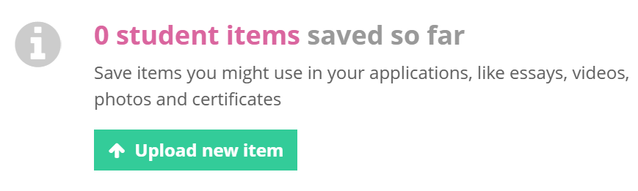
E.g. Joe Bloggs, Work Experience Reflection Journal and upload by clicking on the button

