DISHES | 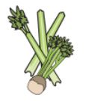 | 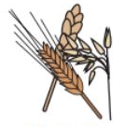 | 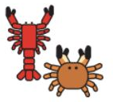 |  | 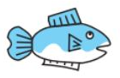 | 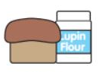 | 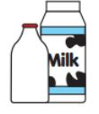  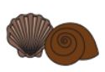 |  | 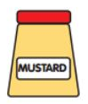 | 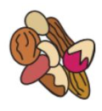 | 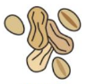 | 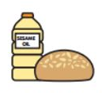 | 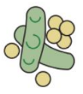 | 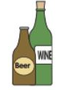
MAIN MEAL WK 3 | Celery | Cereals containing gluten | Crustaceans | Eggs | Fish | Lupin | Milk | Molluscs | Mustard | Nuts | Peanuts | Sesame seeds | Soya | Sulphur dioxide
SALMON TERIYAKI & NOODLES |  | YES |  |  | YES |  |  |  |  |  |  |  | YES
VEGETABLE CHOW MEIN & RICE NOODLES |  |  |  |  |  |  |  |  |  |  |  |  | YES
SHEPHERDS PIE |  |  |  |  |  |  | YES
SHEPHERDLESS PIE |  |  |  |  |  |  |  |  |  |  |  |  | YES
ROAST PORK DINNER
QUORN ROAST DINNER |  |  |  | YES |  |  | YES
CHICKEN KORMA & RICE
KERALAN VEG CHAAT & RICE
BREADED FISH FILLET |  | YES |  |  | YES
QUORN NUGGETS AND CHIPS |  | YES |  |  |  |  |  |  |  |  |  |  | YES
NORTHAMPTON SCHOOL FOR BOYS

