DISHES | 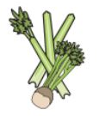 | 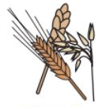 | 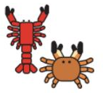 |  |  | 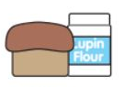 | 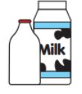  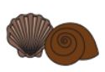 |  | 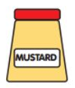 | 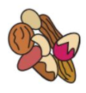 | 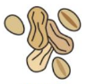 | 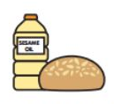 | 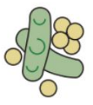 | 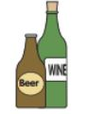
MAIN MEAL WK 2 | Celery | Cereals containing gluten | Crustaceans | Eggs | Fish | Lupin | Milk | Molluscs | Mustard | Nuts | Peanuts | Sesame seeds | Soya | Sulphur dioxide
PESTO CHICKEN PASTA |  | YES |  |  |  |  | YES
CH & TOM PIZZA |  | YES |  |  |  |  | YES
BEEF CHILLI & RICE
VEGAN CHILLI & RICE |  |  |  |  |  |  |  |  |  |  |  |  | YES
ROAST CHICKEN & POTAOTES
ROAST QUORN FILLET DINNER |  | YES
SAUSAGE & MASH |  | YES |  |  |  |  | YES
VEGGIE SAUSAGE AND MASH |  | YES |  |  |  |  | YES
BREADED FISH FILLET |  | YES |  |  | YES
VEGAN SAUSAGE ROLL AND CHIPS |  | YES |  |  |  |  |  |  |  |  |  |  | YES
NORTHAMPTON SCHOOL FOR BOYS

