DISHES | 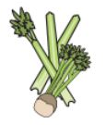 | 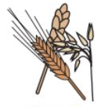 | 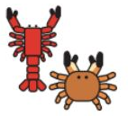 |  | 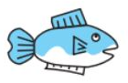 | 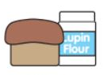 | 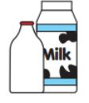  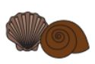 |  | 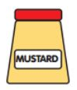 | 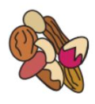 | 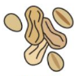 | 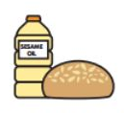 | 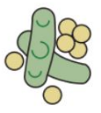 | 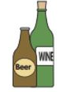
MAIN MEAL WK 1 | Celery | Cereals containing gluten | Crustaceans | Eggs | Fish | Lupin | Milk | Molluscs | Mustard | Nuts | Peanuts | Sesame seeds | Soya | Sulphur dioxide
SPAGHETTI BOLOGNAISE |  | YES
VEGAN BOLOGNAISE |  | YES |  |  |  |  |  |  |  |  |  |  | YES
CHIPOLTLE CHICKEN, WEDGES &SLAW
QUESADILLA WEDGES & SLAW |  | YES |  |  |  |  | YES
ROAST GAMMON, ROAST POTATOES
VEGGIE SAUSAGE & ROAST
CHICKEN TIKKA MASALA & RICE
GOAN QUORN CURRY &RICE |  |  |  |  |  |  | YES
BREADED FISH FILLET & CHIPS |  | YES |  |  | YES
GLUTEN FREE FISH FILLET & CHIPS |  |  |  |  | YES
VEGGIE PIZZA & CHIPS |  | YES |  |  |  |  | YES
ALL CHICKEN HALAL
NORTHAMPTON SCHOOL FOR BOYS

