DISHES | 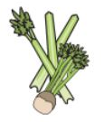 | 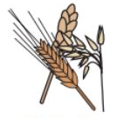 | 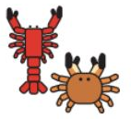 |  |  | 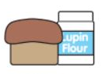 | 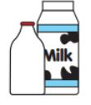   |  | 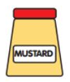 | 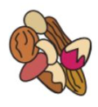 | 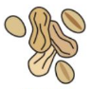 | 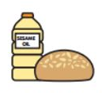 |  | 
GRAB AND GO 2  LUNCH | Celery | Cereals containing gluten | Crustaceans | Eggs | Fish | Lupin | Milk | Molluscs | Mustard | Nuts | Peanuts | Sesame seeds | Soya | Sulphur dioxide
SPICY BEAN BURGER |  | YES
VEGAN CHICKEN BURGER |  | YES |  |  |  |  |  |  |  |  |  |  | YES
QUORN DICED BURRITO  G/F AVAILABLE |  | YES |  | YES
PULLED QUORN WRAP |  | YES
QUORN CHEESEBURGER |  | YES |  | YES |  |  | YES
CHEESE AND TOMATO PIZZINI |  | YES |  |  |  |  | YES
PANINI CHEESE BASED |  | YES |  |  |  |  | YES |  |  |  |  | MAY CONTAIN
MEAT PANINI CHEESE |  | YES |  |  |  |  | YES |  |  |  |  | MAY CONTAIN
MEAT PANINI |  | YES |  |  |  |  | YES |  |  |  |  | MAY CONTAIN
CHIPS & BEANS
NORTHAMPTON SCHOOL FOR BOYS

