DISHES | 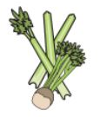 | 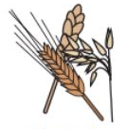 | 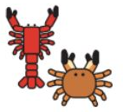 | 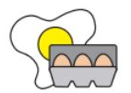 | 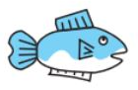 | 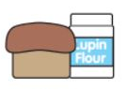 | 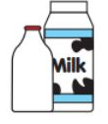  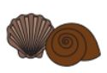 |  | 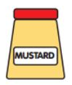 | 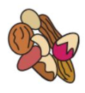 | 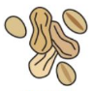 | 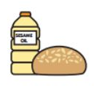 | 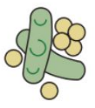 | 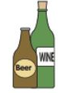
GRAB AND GO | Celery | Cereals containing gluten | Crustaceans | Eggs | Fish | Lupin | Milk | Molluscs | Mustard | Nuts | Peanuts | Sesame seeds | Soya | Sulphur dioxide
BACON AND CHEESE MUFFIN |  | YES |  | MAY CONTAIN |  |  | YES |  |  |  |  |  | MAY CONTAIN
BACON AND EGG MUFFIN |  | YES |  | YES |  |  | MAY CONTAIN |  |  |  |  |  | MAY CONTAIN
½ PIZZA BAGUETTE |  | YES |  |  |  |  | YES
PIZZA SLICE MARGHERITA |  | YES |  |  |  |  | YES
VEGAN SAUSAGE ROLL |  | YES |  |  |  |  |  |  |  |  |  |  | YES
VEGAN WAFFLE |  | YES |  | MAY CONTAIN |  |  | MAY CONTAIN
BACON BAGUETTE |  | YES |  |  |  |  |  |  |  |  |  | MAY CONTAIN
BACON AND CHEESE BAGEL |  | YES |  |  |  |  | MAY CONTAIN
QUORN DOG |  | YES |  | YES |  |  |  |  |  |  |  | MAY CONTAIN
QUORN SAUSAGE AND EGG MUFFIN |  | YES |  | YES |  |  | YES |  |  |  |  |  | MAY CONTAIN
NORTHAMPTON SCHOOL FOR BOYS

