DISHES | 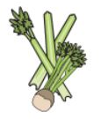 | 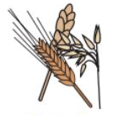 | 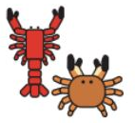 | 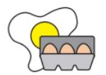 | 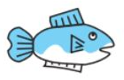 | 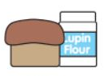 | 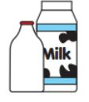 | 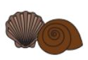 | 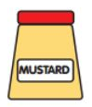 | 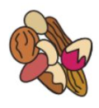 | 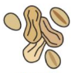 | 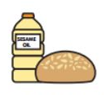 | 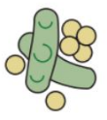 | 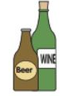
GRAB AND GO | Celery | Cereals containing gluten | Crustaceans | Eggs | Fish | Lupin | Milk | Molluscs | Mustard | Nuts | Peanuts | Sesame seeds | Soya | Sulphur dioxide
GARLIC BREAD |  | YES |  |  |  |  | MAY CONTAIN |  |  |  |  |  | MAY CONTAIN
PIRI PIRI WINGS | MAY CONTAIN | MAY CONTAIN |  |  |  |  | MAY CONTAIN |  | MAY CONTAIN |  |  |  | MAY CONTAIN | MAY CONTAIN
CHINESE WINGS | MAY CONTAIN | YES BARLEY |  |  |  |  | MAY CONTAIN |  | MAY CONTAIN |  |  |  | MAY CONTAIN | MAY CONTAIN
BBQ WINGS | MAY CONTAIN | YES |  |  |  |  | MAY CONTAIN |  | MAY CONTAIN |  |  |  | YES | MAY CONTAIN
JERK WINGS | MAY CONTAIN | YES BARLEY |  | MAY CONTAIN |  |  | MAY CONTAIN |  | MAY CONTAIN
SPICY WINGS
BELGIAN WAFFLE |  | YES |  | YES |  |  | MAY CONTAIN |  |  |  |  |  | YES
PRETZEL |  | YES
AMERICAN PANCAKES |  | YES |  | YES |  |  | YES
CHEESY BAGEL |  | YES |  |  |  |  | YES
SAUSAGE ROLL |  | YES |  |  |  |  | YES |  |  |  |  |  | YES | YES
HALAL WINGS SWEET CHILLI
NORTHAMPTON SCHOOL FOR BOYS

